*RequestDispatcher*

It is interface which is used to dispatching the request to another resource such as HTML, JSP, servlet etc.

There are two methods in RequestDispatcher as below

# public void forward(ServletRequest request,ServletResponse response)throws ServletException,java.io.IOException-

It forwards a request from a servlet to another resource (servlet, JSP file, or HTML file) on the server.

# public void include(ServletRequest request,ServletResponse response)throws ServletException,java.io.IOException-

It includes the content of a resource (servlet, JSP page, or HTML file) in the response.

forward method-

As you see in the below figure, response of second servlet is sent to the client. Response of the first servlet is not displayed to the user.

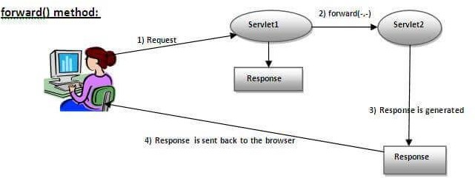

Syntax- public RequestDispatcher getRequestDispatcher(String resource);

Example-RequestDispatcher rd=request.getRequestDispatcher("success.jsp"); rd.forward(request, response);

Note- in this example, The return type of getRequestDispatcher() method is RequestDispatcher that’s why we are able to write RequestDispatcher rd;

rd is the reference of RequestDispatcher interface. include method-

As you can see in the below figure, response of second servlet is included in the response of the first servlet that is being sent to the client.

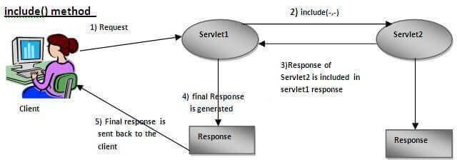

Syntax- public RequestDispatcher getRequestDispatcher(String resource); Example-RequestDispatcher rd=request.getRequestDispatcher("success.jsp");

rd.include(request, response);

***JSP + Servlets CRUD operation* Register.jsp**

<%@ page language=*"java"* contentType=*"text/html; charset=ISO-8859-1"*

pageEncoding=*"ISO-8859-1"*%>

<!DOCTYPE html>

<html>

<head>

<meta charset=*"ISO-8859-1"*>

<title>Insert title here</title>

</head>

<body>

<form action=*"SaveServlet"*>

Username::<input type=*"text"* name=*"username"*> Password::<input type=*"password"* name=*"password"*>

<input type=*"submit"* value=*"submit"*> </button>

</form>

<a href=*"ViewServlet"*>View Employee List</a>

</body>

</html>

**Employee.java**

**package** com.test;

**public class** Employee {

**int** id;

String username; String password;

**public int** getId() {

**return** id;

}

**public void** setId(**int** id) {

**this**.id = id;

}

**public** String getUsername() {

**return** username;

}

**public void** setUsername(String username) {

**this**.username = username;

}

**public** String getPassword() {

**return** password;

}

**public void** setPassword(String password) {

**this**.password = password;

}

@Override

**public** String toString() {

**return** "Employee [id=" + id + ", username=" + username + ", password=" + password + "]";

}

}

**SaveServlet.java**

package com.test;

import java.io.IOException; import java.util.ArrayList; import java.util.List;

import javax.servlet.RequestDispatcher;

import javax.servlet.ServletException; import javax.servlet.annotation.WebServlet; import javax.servlet.http.HttpServlet;

import javax.servlet.http.HttpServletRequest; import javax.servlet.http.HttpServletResponse; @WebServlet("/*SaveServlet* ")

public class SaveServlet extends HttpServlet {

private static final long serialVersionUID = -711373866551588448L;

protected void service (HttpServletRequest request, HttpServletResponse response)

throws ServletException, IOException {

//get the data from user

String name = request.getParameter("username"); System.out.println("name>>" + name);

String pass = request.getParameter("password"); System.out.println("pass>>" + pass);

//process the data

Employee employee= new Employee(); employee.setUsername(name);

employee.setPassword(pass);

DBUTIL.save(employee);

}

}

**ViewServlet.java**

**package** com.test;

**import** java.io.IOException;

**import** java.io.PrintWriter;

**import** java.util.List;

**import** javax.servlet.ServletException;

**import** javax.servlet.annotation.WebServlet;

**import** javax.servlet.http.HttpServlet;

**import** javax.servlet.http.HttpServletRequest;

**import** javax.servlet.http.HttpServletResponse;

/**

* Servlet implementation class ViewServlet

*/ @WebServlet("/ViewServlet")

**public class** ViewServlet **extends** HttpServlet {

**private static final long *serialVersionUID*** = 1L;

**protected void** doGet(HttpServletRequest request, HttpServletResponse response) **throws** ServletException, IOException {

PrintWriter out= response.getWriter(); out.print("<h1>Employee List>></h1>"); List<Employee> list=DBUTIL.*getAllEmployee*(); System.***out***.println("list>>"+list);

out.print("<table border=1 width='100%'>");

out.print("<tr><th>ID</th><th>Username</th><th>Password<

/th>");

**for**(Employee e: list) {

out.print("<tr><td>"+e.getId()+"</td><td>"+e.getUsername ()+"</td><td>"+e.getPassword()+"</td><td><a href='DeleteServlet?id="+e.getId()+"'>Delete</a></td></tr>")

;

}

}

}

**DeleteServlet.java**

package com.test;

import java.io.IOException;

import javax.servlet.ServletException; import javax.servlet.annotation.WebServlet; import javax.servlet.http.HttpServlet;

import javax.servlet.http.HttpServletRequest; import javax.servlet.http.HttpServletResponse;

/**

* Servlet implementation class DeleteServlet

*/ @WebServlet("/DeleteServlet")

public class DeleteServlet extends HttpServlet {

private static final long serialVersionUID = 1L;

protected void doGet(HttpServletRequest request, HttpServletResponse response)

throws ServletException, IOException {

String empId=request.getParameter("id"); int id=Integer.parseInt(empId);

//System.out.println("id>>"+id); DBUTIL.delete(id);

}

}

DBUTIL.java

**package** com.test;

**import** java.sql.Connection;

**import** java.sql.DriverManager; **import** java.sql.PreparedStatement; **import** java.sql.ResultSet;

**import** java.sql.SQLException;

**import** java.util.*;

**public class** DBUTIL {

// design utility for connection

**public static** Connection getConnection() **throws**

SQLException {

Connection con = **null**;

**try** {

Class.*forName*("com.mysql.cj.jdbc.Driver");

con =

DriverManager.*getConnection*("jdbc:mysql://localhost:3306/tes t", "root", "root");

} **catch** (ClassNotFoundException e) { e.printStackTrace();

}

**return** con;

}

**public static void** save(Employee employee) {

# try {

Connection con = DBUTIL.*getConnection*(); PreparedStatement ps =

con.prepareStatement("insert into employee(username,password)values(?,?)");

ps.setString(1, employee.getUsername()); ps.setString(2, employee.getPassword());

ps.executeUpdate(); con.close();

} **catch** (Exception e) {

e.printStackTrace();

}

}

**public static** List<Employee> getAllEmployee() {

List<Employee> list = **new** ArrayList<Employee>();

# try {

Connection con = DBUTIL.*getConnection*();

PreparedStatement ps = con.prepareStatement("select * from employee");

ResultSet rs = ps.executeQuery();

**while** (rs.next()) {

Employee employee = **new** Employee(); employee.setId(rs.getInt(1)); employee.setUsername(rs.getString(2)); employee.setPassword(rs.getString(3)); list.add(employee);

}

} **catch** (Exception e) {

e.printStackTrace();

}

**return** list;

}

**public static int** delete(**int** id) {

**int** status=0;

# try {

Connection con = DBUTIL.*getConnection*(); PreparedStatement ps =

con.prepareStatement("delete from employee where id=?");

ps.setInt(1, id);

status=ps.executeUpdate();

} **catch** (Exception e) {

e.printStackTrace();

}

**return** status;

}

}